**Installing Eclipse**

For Android, the installer file used is called an apk file, to obtain this file from the provided code Eclipse will need to be downloaded and installed onto your computer. It has support for both Windows and Mac, this software can be downloaded from [*http://developer.android.com/sdk/index.html*](http://developer.android.com/sdk/index.html).

Once Eclipse has been installed, open it and you should be prompted to choose a workspace location on your computer. A workspace is simply a directory that all programs developed within Eclipse will be saved to. The window that will appear will be similar to figure below

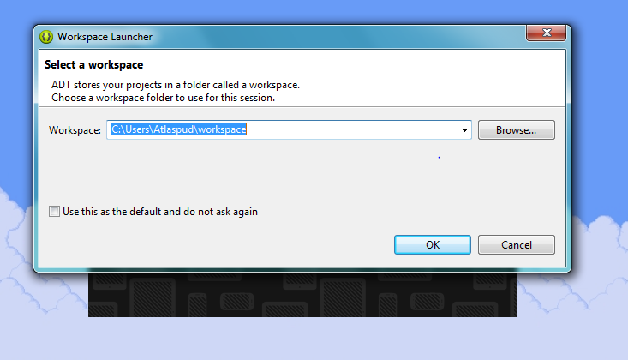

Figure ***

Once the workspace location has been defined, the Eclipse will run.

Loading the Bluetooth Controller Program

To load the Bluetooth application program, go to file🡪Import

Then go to Android🡪Existing Android Code Into Workspace

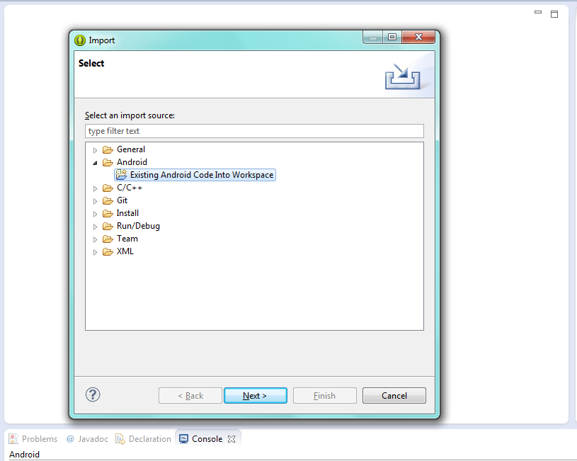

Figure ***

Click next

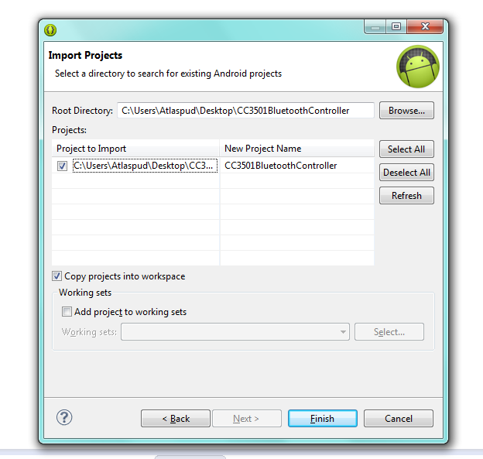

Figure ***

Select browse and search for the provide folder named CC3501 Bluetooth Controller. Make sure the copy projects into workspace is selected and select finish. This will import the developed program into eclipse.

**Creating an apk**

To create the necessary apk to be installed on the android device

Go to file🡪Export🡪Android🡪Export Android Application🡪Next

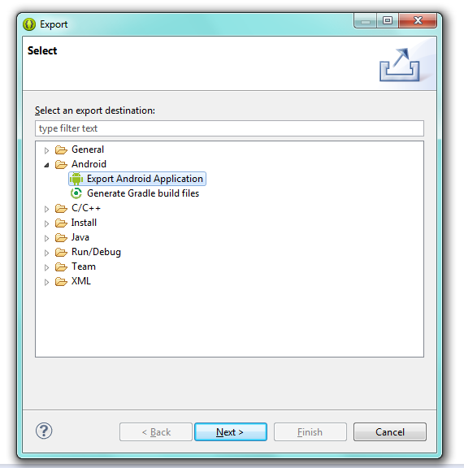

You may need to browse to the project, but in this case if you only have one project loaded it will be displayed already in the box, click next to continue

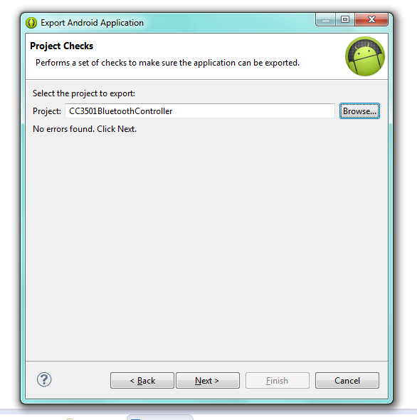

You will now be prompted to search for an existing keystore, or make a new one. A keystore file holds information about a developer so that they don’t have to keep entering the same details when developing multiple apps. A keystore has been provided in the file CC3501BluetoothController, The keystore file is titled

CC3501BluetoothApp and is located in the main folder.

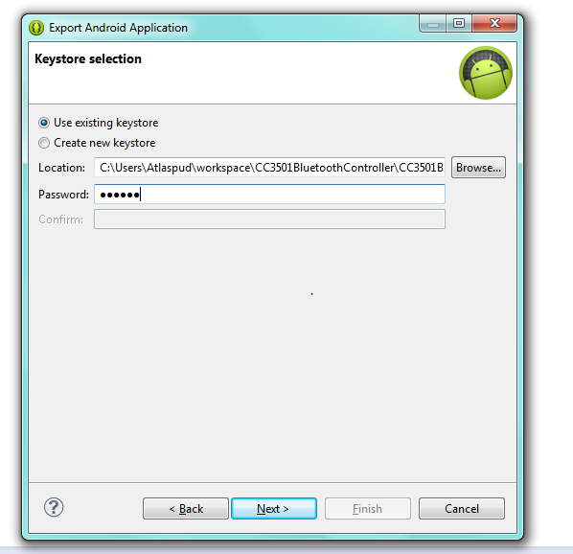

The password set is simply cc3501 all in lowercase, once this is entered click next.

Select the Alias which there will only be one and the password is again cc3501, click next to continue

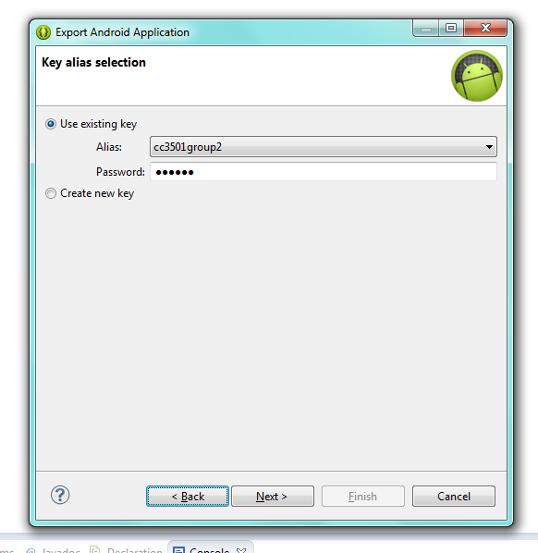

Finally you will be prompted to select a location to save the apk file, just choose the desktop as this makes it easier to load onto an android device later. Select finish and you are done.